**Deck of Cards**

Each deck of cards contains 52 cards, with 13 for each suite. The cards range from 2-10 with picture cards of Ace, Jack, Queen and King. In this experiment, we are going to assume that Ace has a value of 1 and Jack, Queen King have value of 10.

Population Description:

For the first part, assume that we are going to only draw one card at time. Here are the statistics that describe this experiment:

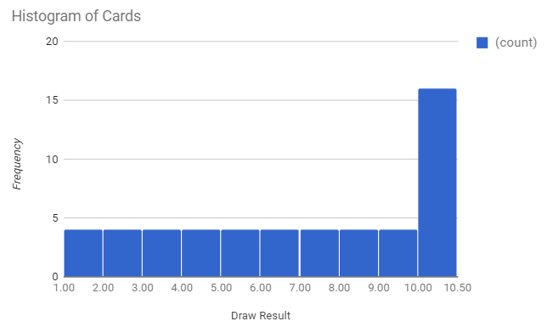

Mean: 6.53

Median: 7

Mode: 10

Variance: 9.94

Std dev: 3.15

Draw 3 Cards:

In this experiment, we are going to draw 3 cards without replacement, meaning that we can only draw the same card once. We are going to do this 30 times to obtain a spread of data and for each three draws we are going to take the average (this is called sample average).

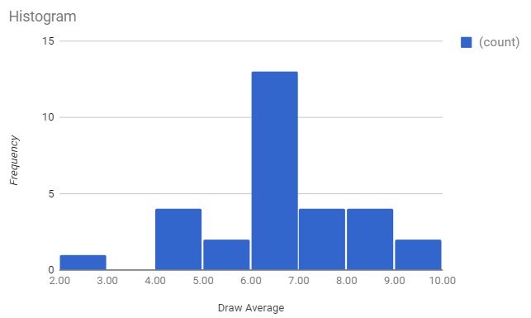

Notice the difference in the shape of distribution. While the first histogram plot looks very skewed to the higher values (this is called negatively skewed histogram), the second histogram shows more like a normal distribution where the most frequent value is the middle one and shows symmetry. This phenomenon occurs due to something called Central Limit Theorem where it states that if the sample is large enough, the mean of all samples from the same population will be approximately equal to the mean of the population.

Mean: 6.41

Median: 6.33

Mode: 6.33

Variance: 2.54

Std error: 1.62

Using descriptive statistics and the values of mean and standard error and facts on normal distribution, we are going to be able to predict the probability of the averages of our future draws.

90% of draw falls to? -1.65 and 1.65 z score (from z table) which equals to 3.66 to 9

Draw value at least 20? Mean = 6.67 – which is 0.33/1.62 = 0.204 which proportion is 0.508 according to z table – so to get at least 20 = 1-0.508 = 0.492